**A CRM APPLICATION FOR SCHOOLS AND COLLEGES**

**INTRODUCTION**

The project aim is to provide real-time knowledge for all the students who have basic knowledge of Salesforce and Looking for a real-time project. This project will also help those professionals who are in cross-technology and want to switch to Salesforce. With the help of this project theymwill gain knowledge and can include it into their resume as well.

Are you new to Salesforce? Not sure exactly what it is, or how to use it? Don’t know where you should start on your learning journey? If you’ve answered yes to any of these questions, then you’re in the right place. This module is for you.  
  
Welcome to Salesforce! Salesforce is game-changing technology, with a host of productivity-boosting features, that will help you sell smarter and faster. As you work toward your badge for this module, we’ll take you through these features and answer the question, “What is Salesforce, anyway?”

**What Is Salesforce?**  
Salesforce is your customer success platform, designed to help you sell, service, market, analyze, and connect with your customers.

Salesforce has everything you need to run your business from anywhere. Using standard products and features, you can manage relationships with prospects and customers, collaborate and engage with employees and partners, and store your data securely in the cloud.

**PURPOSE**

Customer relationship management (CRM) is a technology for managing all your company'srelationships and interactions with customers andpotential customers. The goal is simple:Improve business relationships. A CRM system helps companies stay connected to customers, streamline processes, and improve profitability.

**EMPATHY MAP**

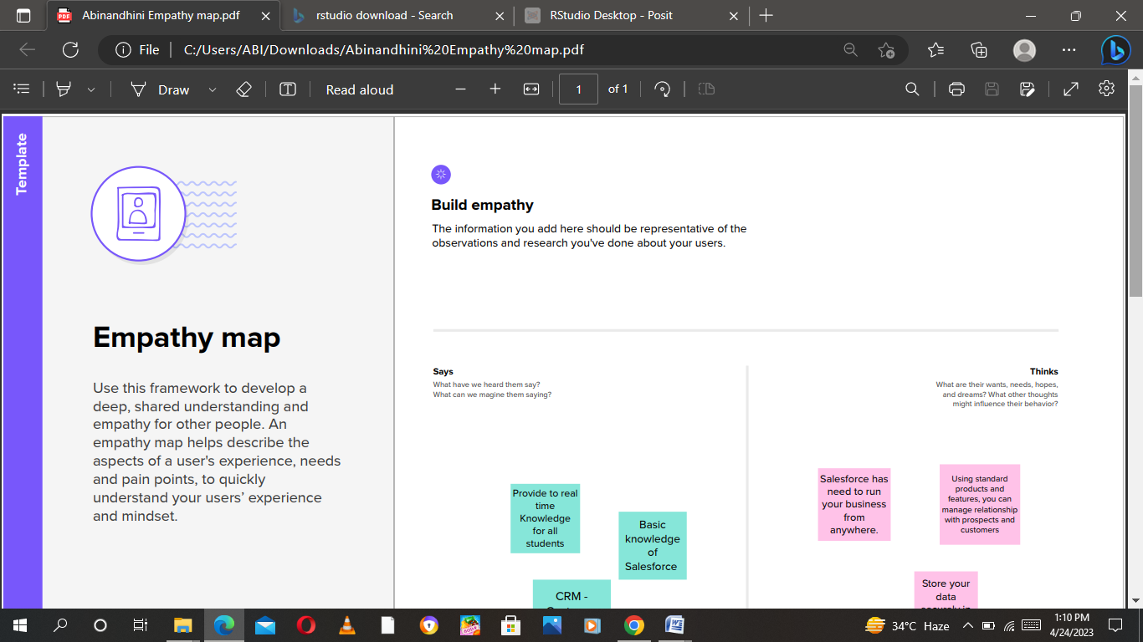

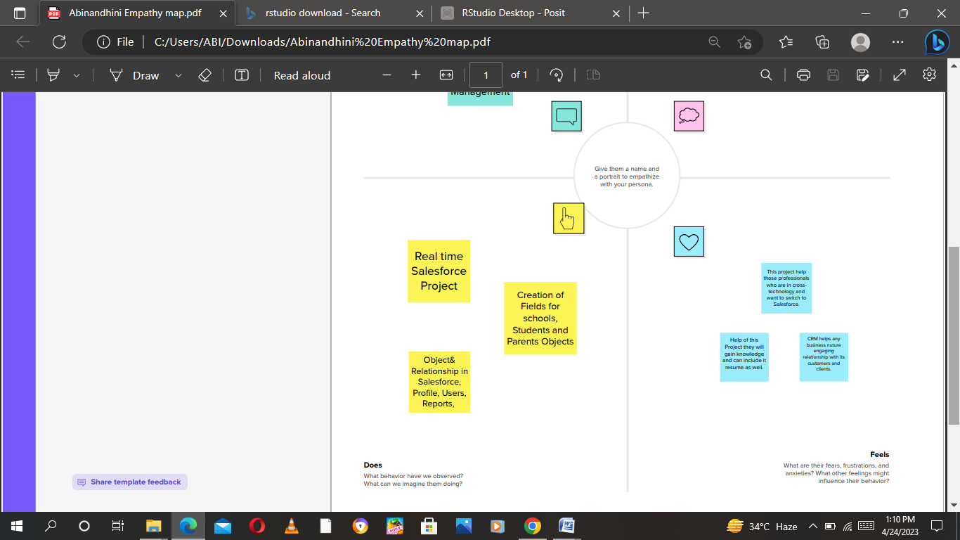

**IDEATION AND BRAINSTORMING MAP**

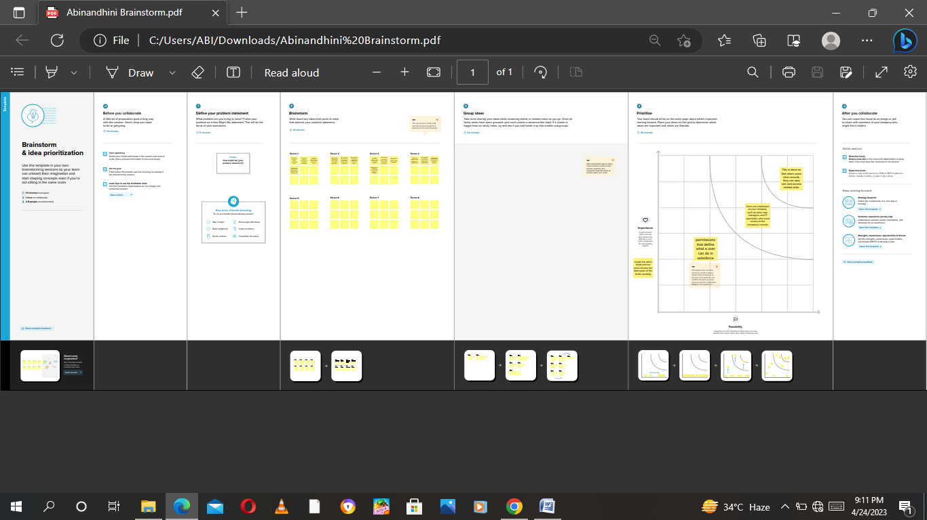

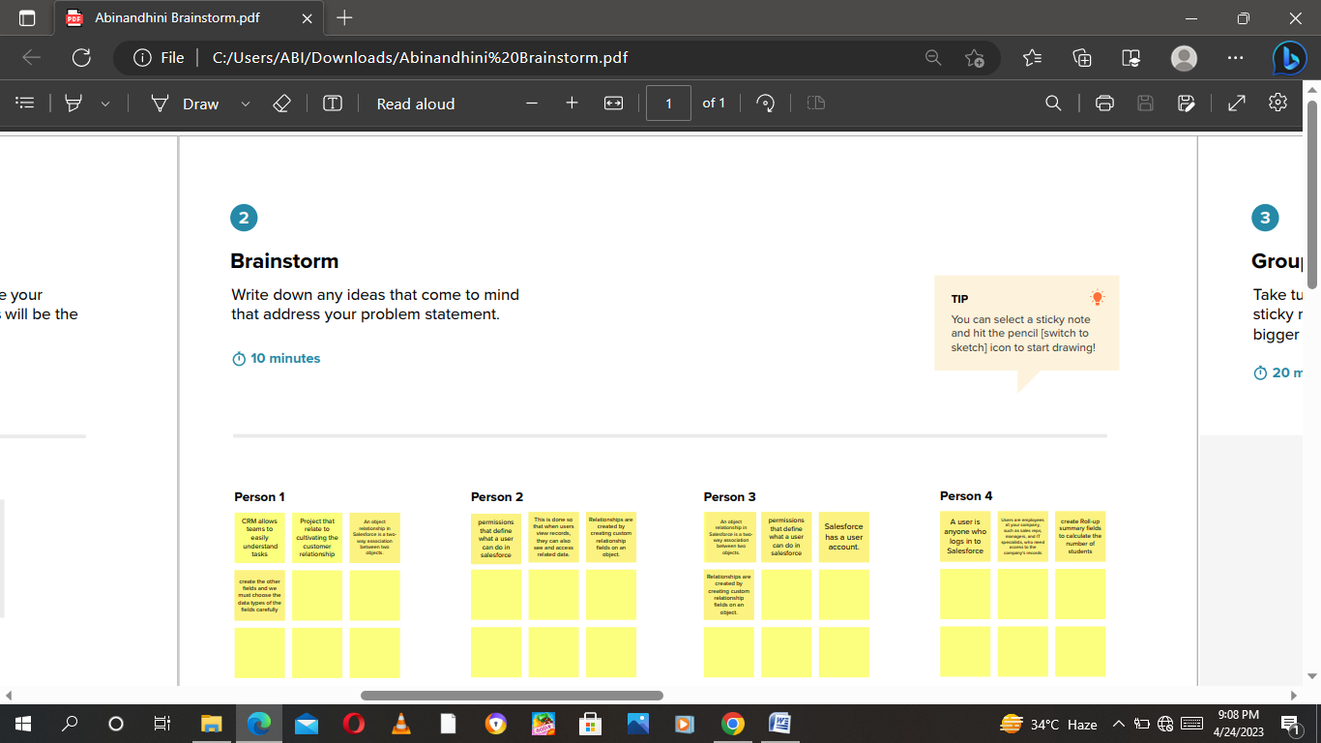

**PROJECT ALONG WITH SCREEN SHOTS**

**Creating Developer Account**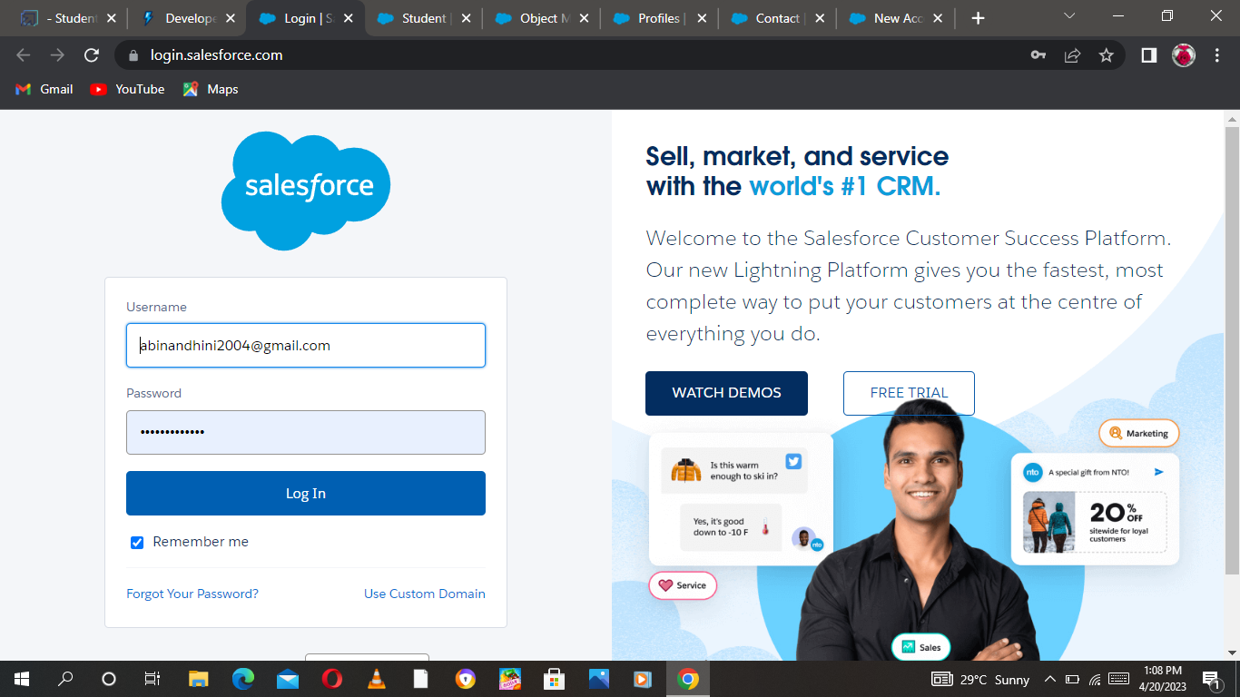

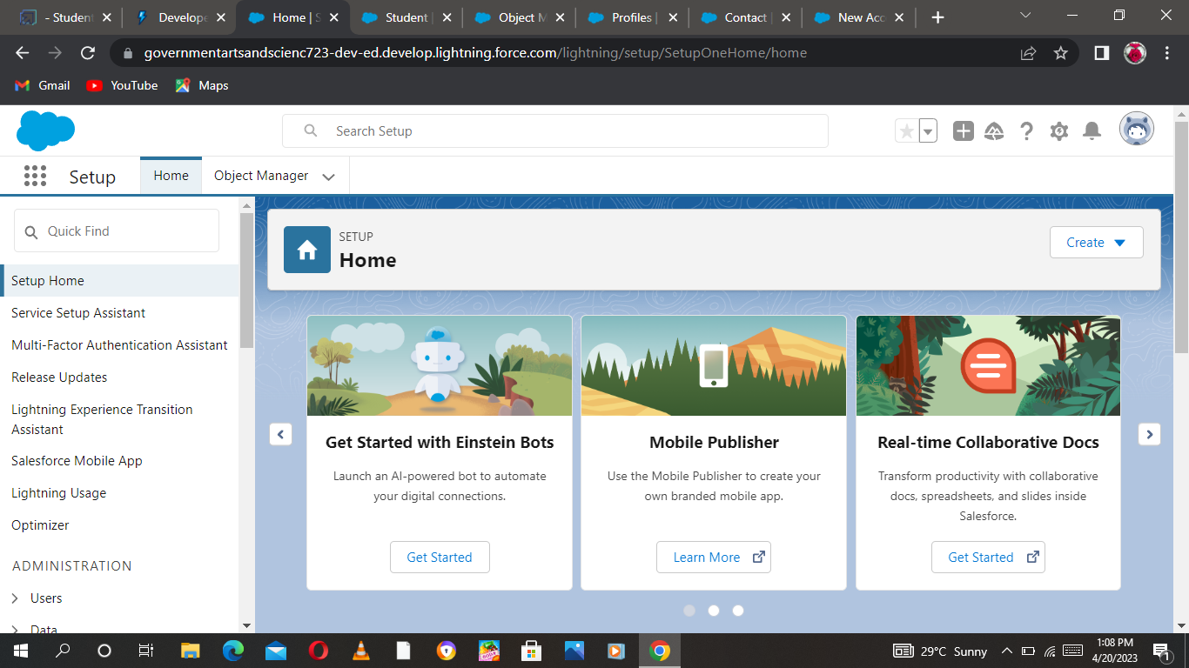

**Object**

**Creation Shool Object**

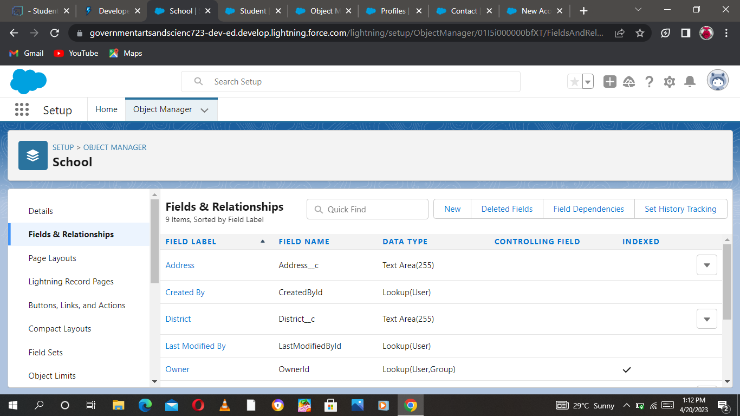

**Creation Student Object**

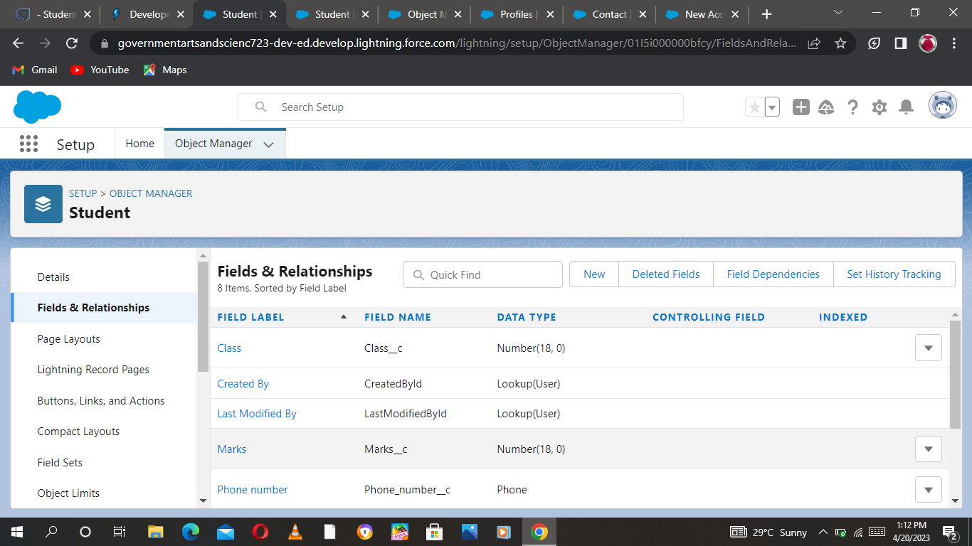

**Creation Parent Object**

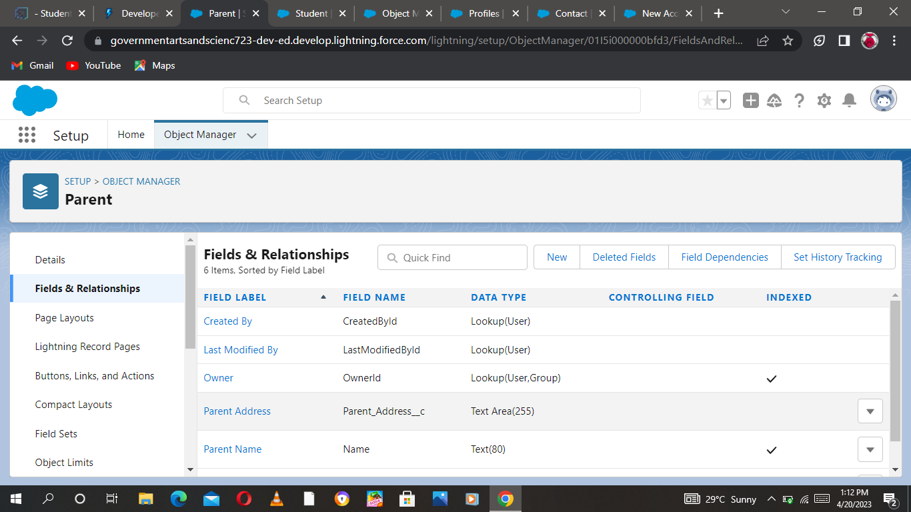

**Create The School Management**

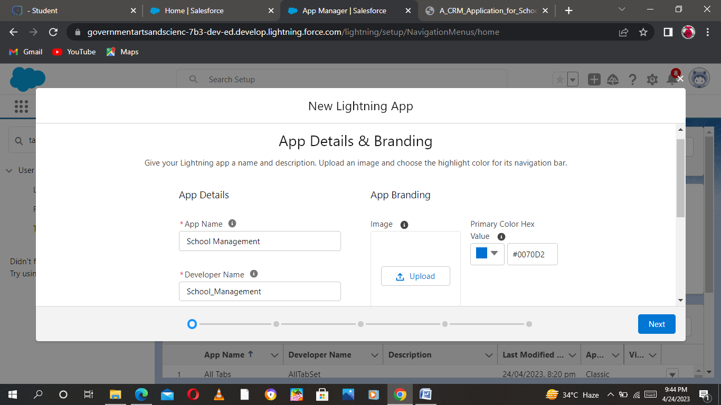

**Fields and Relationship**

An object relationship in Salesforce is a two-way association between two objects.

Relationships are created by creating custom relationship fields on an object.  
  
This is done so that when users view records, they can also see and access related data.

**Field for School Object**

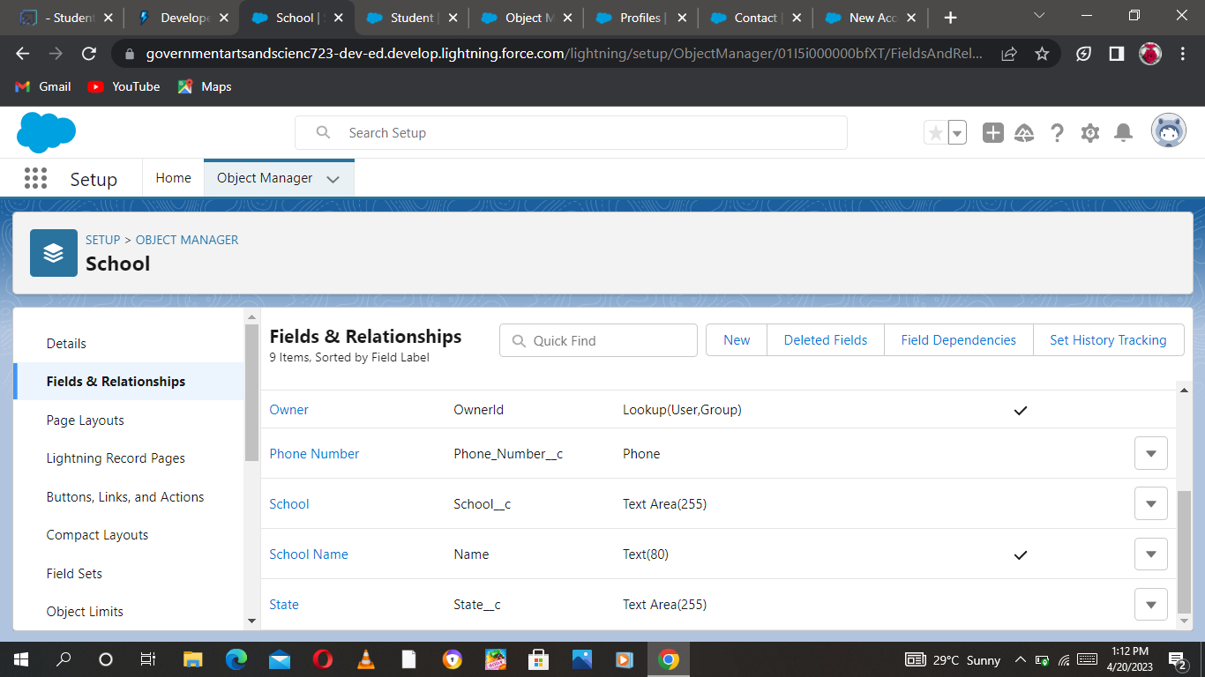

**Field for School Object**

**Field for Parent Object**



**Profile**

A profile is a group/collection of settings and permissions that define what a user can do in salesforce. A profile controls “Object permissions, Field permissions, User permissions, Tab settings, App settings, Apex class access, Visualforce page access, Page layouts, Record Types, Login hours & Login IP ranges

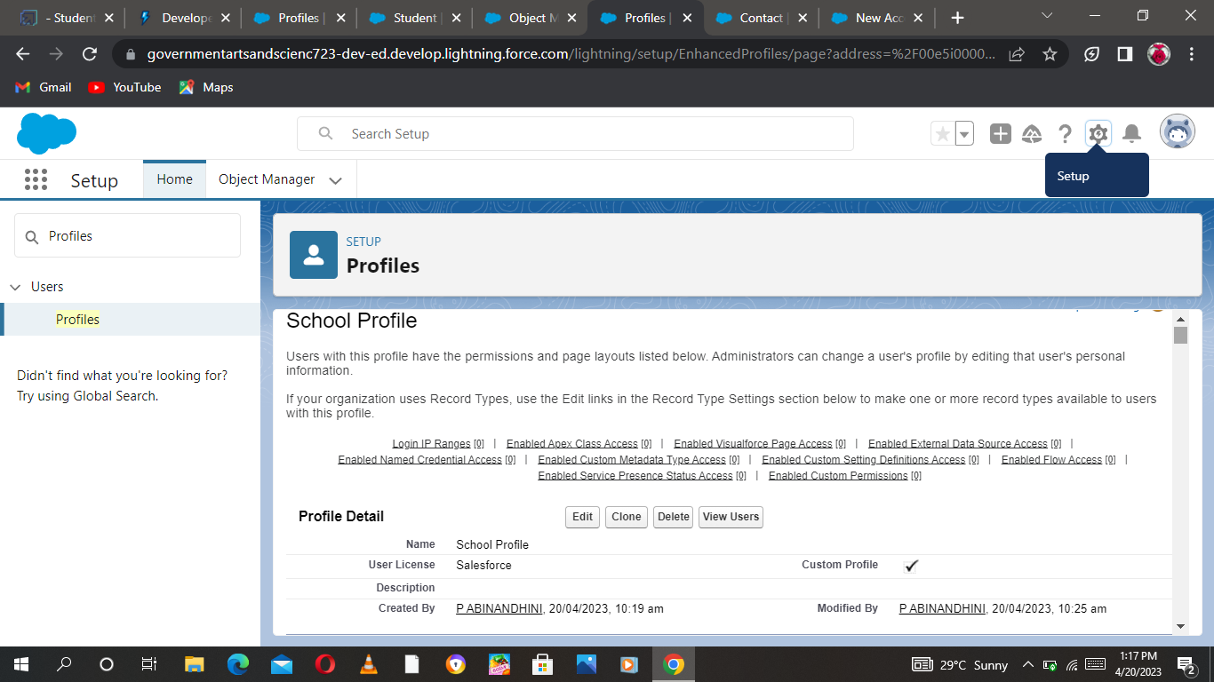

**Users**

A user is anyone who logs in to Salesforce. Users are employees at your company, such as sales reps, managers, and IT specialists, who need access to the company's records. Every user in

Salesforce has a user account.

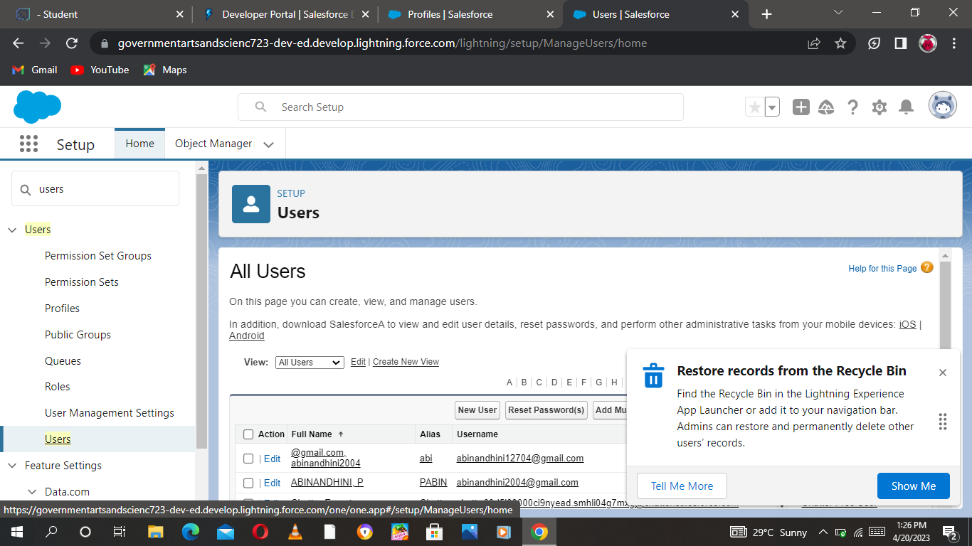

**Permission Sets**

A permission set is a collection of settings and permissions that give users access to various tools and functions. Permission sets extend users' functional access without changing their profiles.

**Permission sets 1**

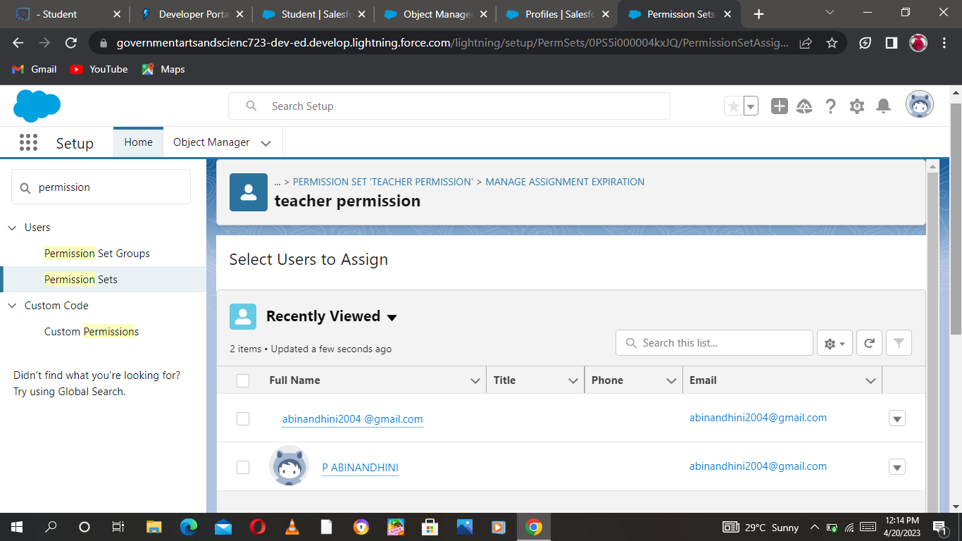

**Permission sets 2**

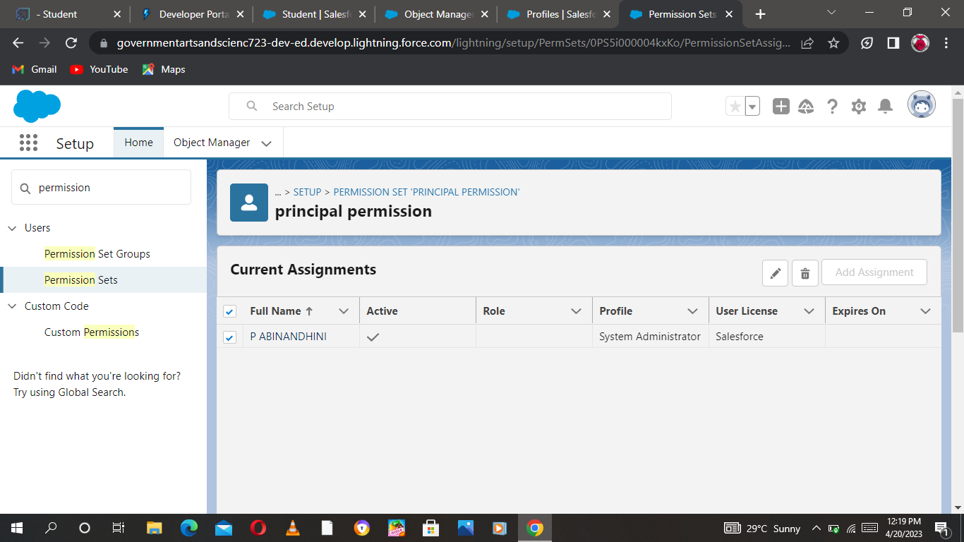

**Reports**

A report is a list of records that meet the criteria you define. It's displayed in Salesforce in rows and columns, and can be filtered, grouped, or displayed in a graphical chart. Every report is stored in a folder. Folders can be public, hidden, or shared, and can be set to read-only or read/write.

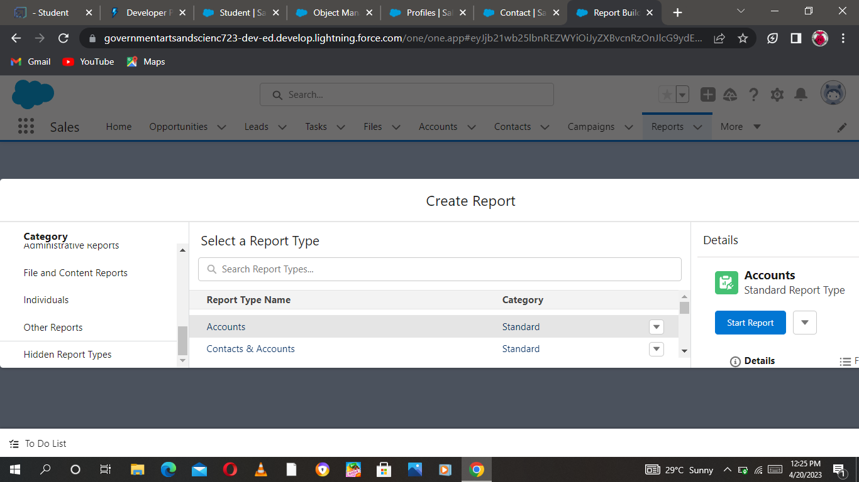

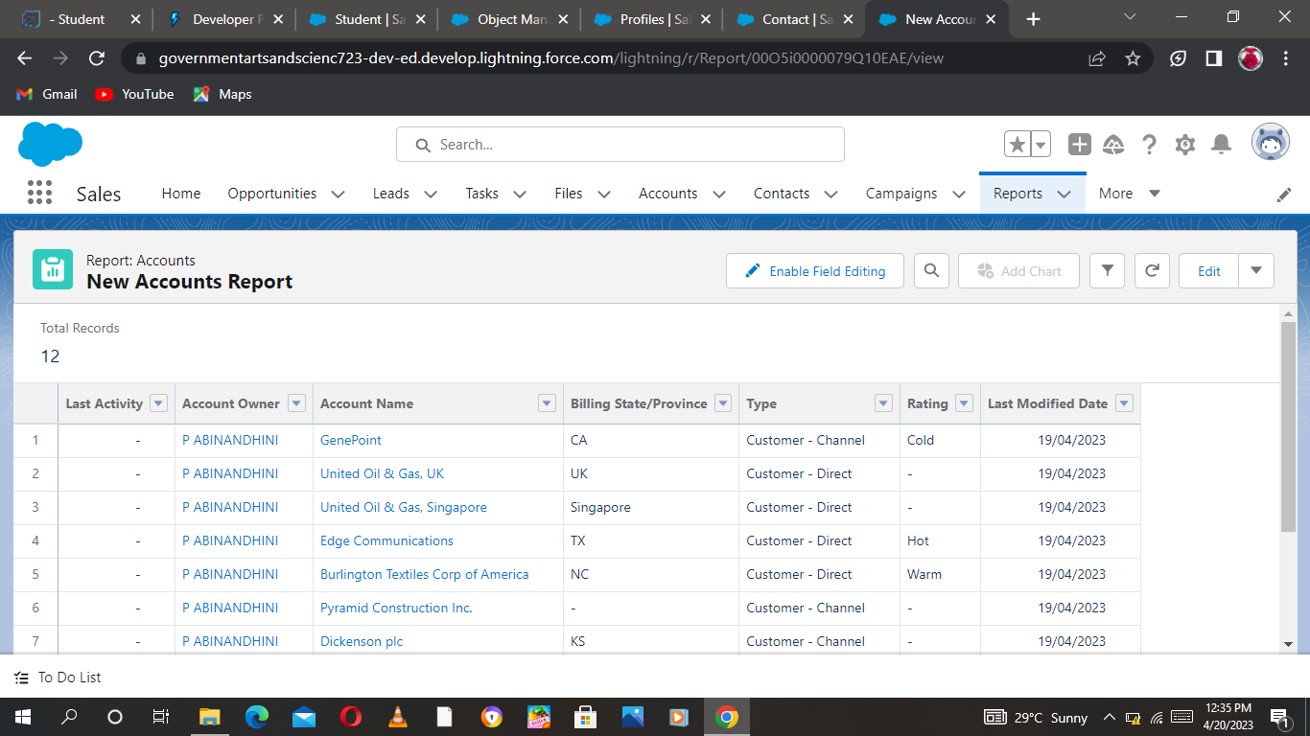

**ADVANTAGES AND DISADVANTAGES**

**It allows for more effective sales and marketing.**

Having huge amounts of data on **customer interactions** enables an organisation to build up a clearer picture of its customers. It allows for deep insights to identify what the company is doing right as well as where it’s weak when it comes to managing its customers. With a CRM system, the most profitable customers can be identified, with the view to more time being spent targeting them. The CRM software also lets a business tailor its marketing communications to achieve more effective results and, hence, a greater return on investment in sales and marketing.

**It can speed up the sales conversion process.**

A CRM system integrated within a marketing campaign allows insights into the interests of prospective customers. Once the client enters the sales funnel, qualification and conversion can be full or partly automated making it much faster. This, whilst enhancing the sales experience, also frees up the sales team’s time, enabling them to focus on closing high probability and/or high-value deals.

**It increases staff productivity, lowers time costs and boosts morale.**

Quaint as it may seem, paperwork is still a significant part of many businesses’ day-to-day operations. A lot of that paperwork could be eliminated with a CRM system. Cutting down on wasted time increases the ability of the employee to get on with the kind of work that brings real value to the organisation. Slashing busy-work means that profit per employee rises, all the while increasing morale as staff feels that their work is more essential and rewarding. All of this fits neatly in with the kind of lean management practices that high-performing businesses utilize.

**It enables widely dispersed teams to work closely.**

Companies often have parts of their operations away from their home base for a multitude of reasons—cheaper operating costs, proximity to clients, or greater ease in providing on-site technical support. A remotely accessible CRM software allows a company to exploit the efficiencies and benefits of multiple geographical locations. This is a huge advantage for sales teams in the field as it gives them the facility to spend more time with prospects and clients. Most importantly though, an organisation fully integrated by means of a CRM system can respond far more effectively to customer queries and issues.

**Can improve customer loyalty through exceptional experience.**

The hallmark of excellent **customer service** is being able to intelligently and quickly address queries and problems. This can only be achieved by being able to efficiently access customers’ data and transactional history allowing for instant familiarization with their context and needs. A CRM system helps speed up processes, enabling employees to deal with more queries and providing a generally better customer experience. An investment in a CRM system is an investment in customer loyalty and the return on that investment comes in the form of an increase in customers’ lifetime value and word-of-mouth referrals.

**DISADVANTAGES**

**Staff over-reliance on CRM may diminish customer loyalty through a bad experience.**

If staff come to rely too heavily on **CRM software**, it reduces their flexibility in dealing with customer queries. They often become helpless in the face of questions from clients where the information isn’t on the system and which requires lateral thinking to solve the problem. This has obvious implications for the customer experience and clients may become frustrated, taking their business to a competitor.

**Security concerns associated with centralised data.**

There are risks associated with keeping a lot of data in one place. With stringent regulations surrounding data (GDPR, for example), businesses face severe penalties in the event of security breaches. When it comes to CRM software, it is vital that security processes are put in place to protect clients’ personal information. This can be a significant expense for a business, but the costs associated with not having such safeguards in place are far higher.

**The excess initial time and productivity cost of implementation**

There will be a steep learning curve for staff with any new system. It will take some time for employees to find their feet with the CRM system and mistakes will be made. It’s for the management team to ensure that there’s adequate buy-in and support in the process of transitioning. This can be expensive as it distracts manpower from their core tasks. The benefits when the CRM system *is*in place, however, will far outweigh the initial time and productivity costs.

**It requires a process-driven sales organisation.**

To maximize the return on investment (ROI) in a CRM system, it is necessary to have a process-driven sales regime. A CRM can be used simply as a data store that can be mined for insights, assuming that that data is updated consistently. However, the real value comes from using it to manage the sales pipeline, flagging issues early and holding people to account. This reduces lost deals, increases upsell rates and provides much-improved revenue forecasting. Where no formal sales process exists, introducing one can be a massive change for some companies—one which may require extensive investment in people, retraining, a whole philosophical shift in the business’ sales approach and quite a lot of short-term expense and pain.

**It may not suit every business.**

Certain businesses where customer transactions are highly standardised may not benefit from a CRM system. A CRM system works best where personalisation is required in client/company interactions and where there are multiple touch-points over time between the client and the business across departments. For example, a CRM system wouldn’t do McDonald’s much good, but for something like an insurance brokerage, a CRM system is essential. Marketing teams are able to contact the client with tailored offers; communications are personalised; multiple employees are able to work on customers’ queries. Before choosing a CRM software, whether custom or off-the-shelf, a business needs to ask itself, not only what its objectives and requirements are, but actually if it could really benefit from one at all.

**CONCLUSION**

In this work, a software product was developed – a CRM system with a mobile application for a school. In the course of the work, the processes of modeling, building architecture, and implementation of web application functionality were described. This CRM system is implemented in the educational process of a school and undergoes initial testing. Further development and support of the developed software product are planned. Thanks to a properly designed architecture, these processes will take place without undue delay in adapting the structure of the application.

**FUTURE SCOPE**

Customer Relationship Management is the best means to reach your customers and serve them in the best way. It automates all those tasks which enterprises used to perform manually. Every organization is set up with some frustrated ambitions and targets. The better the performance of your business, the better will be the relationship with your customers. CRM software Development can turn your business into a powerhouse of sales. Thus, CRM software is no longer essential in fact mandatory for small and medium businesses. Now, you can easily access the CRM software virtually from anywhere and anytime. All you need an internet connection to further the scope of doing your business. So, don’t be late and perform the necessities for implementing the CRM software in your business.

**APPENDIX**

**Team Leader** – P. ABINANDHINI

[**https://trailblazer.me/id/pabinandhini**](https://trailblazer.me/id/pabinandhini)

**Team Member** – R. ABITHA

[**https://trailblazer.me/id/abitr8**](https://trailblazer.me/id/abitr8)

**Team Member** – V. AARTHI

[**https://trailblazer.me/id/aarthi145**](https://trailblazer.me/id/aarthi145)

**Team Member** – J. ABINAYA

[**https://trailblazer.me/id/abinaya123**](https://trailblazer.me/id/abinaya123)